**Home Equity Reverse Mortgage Information Technology**

**(HERMIT)**

**HERMIT System Changes – Release 6.0**

**Release Date: 04/25/20**

**Document Date: 04/21/20**

April 2020

**INTRODUCTION**

The Home Equity Reverse Mortgage Information Technology (HERMIT) software release version 6.0 consists of the following system changes:

Table of Contents

Servicer Related Changes 2

1. Curtailment of CT22 MOE Assignment when timeline not initiated within 180 days from latest borrower death date 2

2. Reports: Update field Claim Paid Amt on Claims Detail Report 5

3. Claims Warning Message for Short Sale Claims for D&P Event 5

4. Claims Block 121c - Recalculate DBI on CT24 when Curtailment Date is changed 7

NSC Related Changes 13

5. ASSIGNED: Update Limit for Bulk Printing Letters to 600 13

6. ASSIGNED: New Repay Transaction for Property Charges on loans serviced by HUD Contractor 15

7. ASSIGNED: Notes Disbursement Through Treasury 17

If you have any questions regarding the functionality of the software release, please contact the HERMIT Help Desk at 561-899-2610 or at [servicingsupport@hermitsp.com](mailto:support@hecmsp.com). If you have any policy related questions, please send an email to HUD at [answers@hud.gov](mailto:answers@hud.gov).

# Servicer Related Changes

## Curtailment of CT22 MOE Assignment when timeline not initiated within 180 days from latest borrower death date

The Claim Type 22 Assignment on Mortgagee Optional Election (MOE) claims is subject to Curtailment as stated in Mortgagee Letter 2019-15 published on 09/23/20. The system will automatically curtail CT22 MOE Assignment claims meeting the curtailment criteria. In addition, servicers can now update whether a loan is a MOE Assignment or not prior to submitting a claim by using the MOE Assignment field on the Servicing Management tab. Previously, this was only available during CT22 timeline initiation /setup.

1. “MOE Assignment” field on CT22 timeline initiation (conditional) and on the Servicing Management tab of the CT22 timeline. The purpose of this field is to provide a place where the user can view whether the CT22 is labeled as a MOE Assignment or not, and to allow the user to update the CT22 MOE Assignment indicator if it was set up incorrectly during timeline initiation.
   1. On the CT22 initiation / setup window there is a conditionally displayed field called “MOE Assignment”. This replaces the previous field “Assign prior to MCA reaching 97.5%”.
   2. The “MOE Assignment” check box is displayed on the CT22 initiation / setup screen for loans with FHA Case # Assignment Date before 08/04/14.
   3. The “MOE Assignment” check box is also displayed on the Servicing Mgmt tab of the CT22 timeline. Servicer may check or uncheck this box as necessary prior to submitting the claim.
      1. **Important Note**: Claims validations are now in place to prevent loans from being filed as regular CT22 if they should be MOE CT22, and vice versa. See below for details on specific validations.
2. Curtailment Rules for CT22 MOE Assignments

Curtailment of CT22 is only assessed when the “MOE Assignment” box on the Servicing Mgmt timeline is checked. Standard CT22 Assignments (with the box unchecked) are not curtailed at this time.

* 1. The CT22 MOE Assignment will **not be curtailed** when the Claim Type 22 – Assignment timeline is initiated / created **within** 180 days of the last surviving borrower / co-borrower death date.
  2. The CT22 MOE Assignment **will be curtailed** when the Claim Type 22 – Assignment timeline is initiated / created **after** the last surviving borrower / co-borrower death date + 180 days.
  3. If curtailed, Curtailment start date is the later of:
     1. 180 days from the effective date of Mortgagee Letter 2019-15. The Effective Date of ML 2019-15 was 09/23/19, 180 days from this date is **03/21/20**
     2. or 180 days from the last surviving borrower’s death date.
     3. **In other words: CT22 MOE Assignments will not have a curtailment date prior to 03/21/20; but those loans are still subject to curtailment.**
  4. If curtailed, Total Claim Amount / Block 17 UPB amount includes Note Interest through the 180th day from last surviving borrower’s date of death (or 03/21/20, whichever is later), and thereafter implement and curtail Debenture Interest (DBI) starting on 181st day.
     1. No change was made to how Principal, MIP, and Service fee is paid.
  5. If curtailed, the Curtailment message *“Auto Curtailed on MM/DD/YYYY. CT22 MOE Assignment was not initiated within 180 days of the Death Date. Note Interest was paid to curtailment date and no DBI was paid.”* is displayed on the following:
     1. Claim Form under Part A “HUD Comments, if Any”
     2. Advice Of Payment (AOP) “Comments”

The Date displayed in the Curtailment Message is the later of last surviving borrower’s Death Date + 181 days or 03/22/20.

1. Validations
   1. **Validation for CT22 Timeline Initiation**: if “MOE Assignment” box is NOT checked and loan has FHA Case # Assign date before 8/4/14 with NBS on the loan; a hard stop validation shall prevent the claim timeline from being created / initiated. The box would need to be checked to initiate this timeline.
      1. Message displayed: “The CT22 must be submitted as MOE Assignment because the MOE indicator is Yes”.
   2. **Validations for CT22 Claim Submission:** 
      1. “This claim cannot be submitted as a MOE Assignment. The loan does not meet the FHA Case Assignment date and NBS requirements.”
         1. Displayed when “MOE Assignment” box is checked and **either** there is no NBS on the loan, **OR** the FHA Case # Assignment Date is ON or After 08/04/14.
      2. “This claim cannot be submitted as a MOE Assignment. All borrowers are not deceased.”
         1. Displayed when “MOE Assignment” box is checked and there is at least one borrower or co-borrower on the loan that is alive.
      3. “This claim cannot be submitted as a MOE Assignment. There are no eligible NBS's on the loan.”
         1. Displayed when “MOE Assignment” box is YES and there is no NBS on the loan.
      4. “This claim must be submitted as a MOE Assignment. The loan meets FHA Case Assignment date and NBS requirements.”
         1. Displayed when “MOE Assignment” box is NOT checked, the loan has an NBS, and FHA Case # Assignment Date is before 08/04/14.
   3. **Existing Validations to remain in place at Timeline Initiation:** 
      1. Loan Balance must be >= 97.5% of the max claim amount
      2. There is currently no eligible NBS (Non Borrowing Spouse) on this loan. Please add the eligible NBS through the HERMIT Contact page.
   4. **Existing Validation to remain in place at claim submission:** 
      1. This claim cannot be submitted until the loan balance surpasses 97.5% of the Max Claim Amount.
         1. Message to be displayed when:
            1. Servicing Mgmt “MOE Assignment” box is NO
            2. Loan Balance is less than 97.5% of the Max Claim Amount
            3. Other Criteria that requires the claim to be submitted as a MOE Assignment is not met
2. Examples
   1. Curtailed CT22 MOE Assignment as of Borrower Death Date + 180 days
      1. “MOE Assignment” box on Servicing management box is checked
      2. Last surviving borrower Death Date: **09/25/19**
      3. Create Date of the CT22 Assignment timeline: **03/31/20**
      4. Death Date + 180 = 03/23/20, the Create Date is after this date therefore the claim will be curtailed.
      5. This curtailment is after 03/21/20 (the effective date of ML 2019-15 +180 days), therefore the Curtailment is based on Death Date + 180. Note interest paid through 03/23/20, Curtailment begins on 03/24/20.
   2. Curtailed CT22 MOE Assignment starting on ML 2019-15 Effective Date + 180 days
      1. “MOE Assignment” box on Servicing management box is checked
      2. Last surviving borrower Death Date: **08/01/19**
      3. Create Date of the CT22 Assignment timeline: **02/15/20**
      4. Death Date + 180 = 01/28/20, the Create Date is after this date therefore the claim will be curtailed.
      5. This curtailment is **BEFORE** 03/21/20 (the effective date of ML 2019-15 +180 days), therefore Curtailment is based on the later date 03/21/20. Note interest paid through 03/21/20, Curtailment begins on 03/22/20.
   3. Not Curtailed
      1. “MOE Assignment” box on Servicing management box is checked
      2. Last surviving borrower Death Date: **08/01/19**
      3. Create Date of the CT22 Assignment timeline: **01/15/20**
      4. Death Date + 180 = 01/28/20, the Create Date is within the allowed timeframe, so the claim will not be curtailed.

## Reports: Update field Claim Paid Amt on Claims Detail Report

An update was made to the field “Claim Paid Amt” on the Claims Detail Report to populate the amount after the claim is Submitted for Payment, instead of after Approved for Payment. This prevents amounts from Cancelled Claim AOP’s from being populated on the Claims Detail Report.

## Claims Warning Message for Short Sale Claims for D&P Event

1. **Warning Message for Short Sale Claims for D&P Event**

New checkbox called “**Short Sale with no Due & Payable** “has been added to the Claims Disposition Screen / “Disposition Information” section for CT23.

Checkbox will be displayed conditionally: Only display if there is NO Active Due & Payable timeline on the loan

Checkbox will be editable (check and uncheck) by users authorized to edit the Claims Disposition screen

**New Hard Stop Validation for CT23 No D&P timeline**

New hard stop claims validation is added: “Short Sale with no D&P timeline must be indicated on claims Disposition Information page or the D&P timeline must be entered.”

New hard stop claims validation will be displayed on CT23 when servicer clicks “Validate Claim” or “Finalize and Submit Claim” if there is no Active D&P timeline in HERMIT AND new field “Short Sale with no Due & Payable” on the Claims Disposition screen is NOT checked

New hard stop validation message shall NOT apply if either of the following apply:

* Either the field “Short Sale with no Due & Payable” is checked and there is no D&P timeline on the loan.
* OR There is an Active D&P timeline on the loan. (In this case, the new field is not be displayed on the disposition screen).

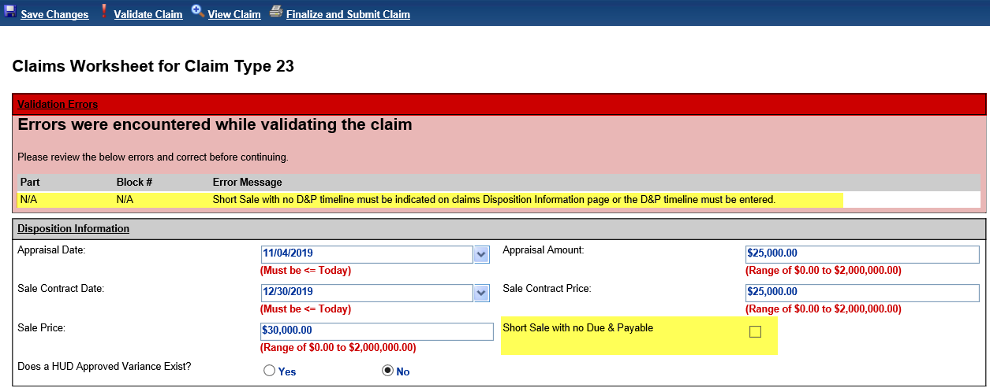

1. **New Hard Stop Validation: CT23 with D&P – Block 8 cannot equal Block 10**

New hard stop validation was added for CT23 where there IS an Active D&P timeline and Block 8 = Block 10: “Short Sale with D&P timeline Block 10 must be after Block 8”

This validation message will apply to CT23’s going forward, but the validation would NOT apply to CT24’s being filed after CT23.

Block 8 and Block 10 can be equal for loans that are not Due & Payable

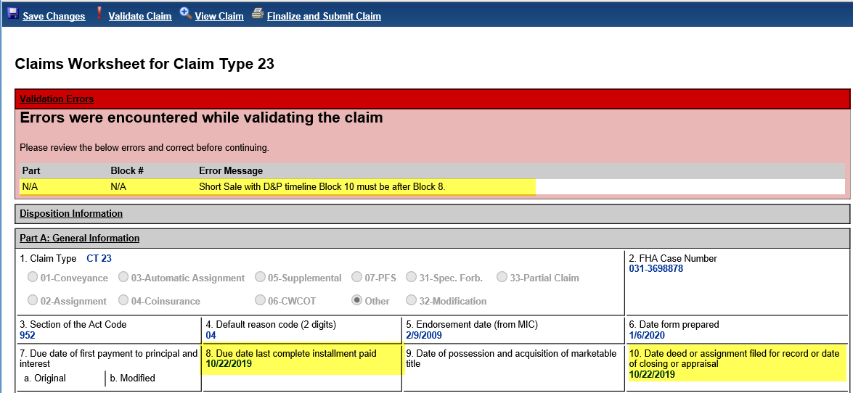

## Claims Block 121c - Recalculate DBI on CT24 when Curtailment Date is changed

HERMIT has been enhanced to auto calculate DBI requests, saving servicers time in calculating the DBI adjustment manually and claim review times to verify this calculation for accuracy. If applicable, HERMIT will now auto-calculate DBI in a CT24 based on the user entering a revised Curtailment Date / “Debenture Interest End Date”. The system’s DBI auto-calculation will populate the amount in block 121C. With this enhancement, Block 121C in the CT24 will no longer be editable by the servicer. Mock Up of new CT24 Disposition Information screen

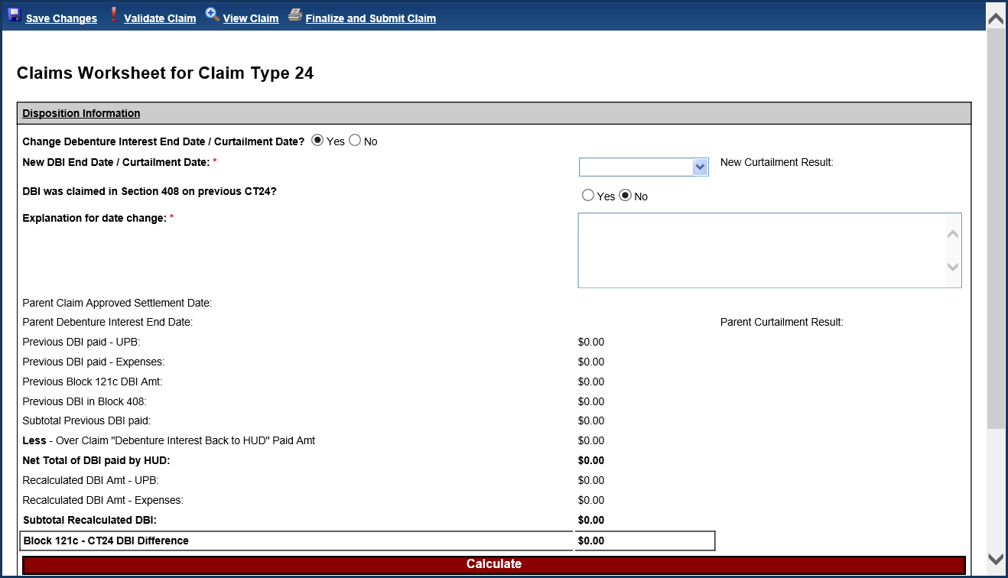

1. To populate Block 121c with auto-calculated amount:
2. Go to the CT24 Disposition Information screen and click YES on field “Change Debenture Interest End Date / Curtailment Date?”
3. Enter appropriate date into field “New DBI End Date / Curtailment Date”. This is the date that Debenture Interest should have been paid to on the original claim.

**TIP**: Block 121c can now be a positive or negative amount. If the amount is negative and the expenses on the claim are sufficient to offset the total claim amount, the claim can still be filed as a positive claim. If the expenses are not sufficient to bring the total claim amount positive, then the DBI amount owed to HUD must be remitted first via the Over Claims process before you can proceed with submitting the CT24 for remaining expenses.

1. Entering “Explanation for date change” is required to justify the change.
2. IF there was any Debenture Interest paid on a previous claim under Block 408, then click “YES” for “DBI was claimed in Section 408 on previous CT24?”. Otherwise leave the field as “No.”

**TIP**: this should only be “Yes” when the current claim is a Subsequent CT24; and is expected to occur rarely.

* 1. Field “Only Input DBI amount claimed in Block 408:” will be displayed.
  2. Input the necessary amount in Block 408 field

1. Click Calculate or Save Changes, then proceed with the claim as usual.
2. Block 121c Rules & Validations:
3. The “New DBI End Date / Curtailment Date” may be before or after the Previous Debenture Interest End Date (this is the AOP “Debenture interest: TO” date). However, the new date must NOT be:
   1. EMPTY: or hard stop validation message will be displayed “New DBI End Date / Curtailment Date is required.”
   2. AFTER “Parent Claim Approved Settlement Date”: will be displayed or hard stop validation message “New DBI End Date / Curtailment Date cannot be greater than Parent Claim Approved Settlement Date.”
   3. BEFORE as follows:
      1. **If Parent was CT21**: New Date cannot be BEFORE Block 29 Due & Payable Date or hard stop validation message will be displayed “New DBI End Date / Curtailment Date cannot be less than the date in Block 29.”
      2. **If Parent was CT23 and FHA Case # Assignment Date is Before 09/19/17:** New Date cannot be BEFORE Block 10 or hard stop validation message will be displayed “New DBI End Date / Curtailment Date cannot be less than or equal to the date in Block 10.”
      3. **If Parent was CT23 and FHA Case # Assignment Date On or After 09/19/17 (Final Rule date):** New Date cannot be BEFORE Block 8 Due & Payable Date. or hard stop validation message will be displayed “New DBI End Date / Curtailment Date cannot be less than or equal to the date in Block 8”
4. When a “New DBI End Date / Curtailment Date” applies, the Claim Form and AOP will display the following message in Part A “HUD Comments, if Any”: “Debenture Interest End Date / Curtailment Date was changed for this claim by servicer.”
5. Text must be typed in box “Explanation for date change” or hard stop validation message will be displayed “Explanation for date change is required.”
6. Block 408 amount. If “YES” is selected on “DBI was claimed in Section 408 on previous CT24?”, then an amount must be entered in field “Only Input DBI amount claimed in Block 408:” or hard stop validation message will be displayed “DBI amount claimed in Block 408 must be entered when DBI was claimed in Block 408 on previous CT24 is selected.”
7. Reporting: The following fields from Claims Disposition Information screen have been added to the Claims Detail Report under Reports > Servicer > Daily Reports:
8. Previous_UPB_DBI
9. Previous_Expenses_DBI
10. Previous_Block_121C
11. Block_408_DBI
12. Over_Claim_DBI
13. Recalculated_UPB_DBI
14. Recalculated_Expenses_DBI
15. Block_121C
16. DBI_Date_Change_Reason
17. New_DBI_End_Date___Curtailment_Date

The field “Block_121C” is populated with Block 121C amount any time it appeared on the claim record and is not restricted to the auto-calculated. In other words, this field includes manually entered Block 121C amounts. All other new fields on the report are only displayed when “YES” was populated on field “New DBI End Date / Curtailment Date”, and therefore applies only when Block 121C was auto-calculated.

1. HERMIT Claims Disposition Information field mapping & Calculations

| **Field Name** | **Data Type** | **Validations** | **Description** |
| --- | --- | --- | --- |
| Change Debenture Interest End Date / Curtailment Date? | Yes / No button, editable | If result is YES, field "New DBI End Date / Curtailment Date" must be populated |  |
| New DBI End Date / Curtailment Date | Date, editable | If "Change Debenture Interest End Date / Curtailment Date?" is YES, field must be populated.   The “New DBI End Date / Curtailment Date” may be before or after the Previous Debenture Interest End Date (this is the AOP “Debenture interest: TO” date). However, the new date must NOT be: a. EMPTY: or hard stop validation message will be displayed “New DBI End Date / Curtailment Date is required.”  b. AFTER “Parent Claim Approved Settlement Date”: will be displayed or hard stop validation message “New DBI End Date / Curtailment Date cannot be greater than Parent Claim Approved Settlement Date.”  c. BEFORE as follows:  i. If Parent was CT21: New Date cannot be BEFORE Block 29 Due & Payable Date or hard stop validation message will be displayed “New DBI End Date / Curtailment Date cannot be less than the date in Block 29.”  ii. If Parent was CT23 and FHA Case # Assignment Date is Before 09/19/17: New Date cannot be BEFORE Block 10 or hard stop validation message will be displayed “New DBI End Date / Curtailment Date cannot be less than or equal to the date in Block 10.”  iii. If Parent was CT23 and FHA Case # Assignment Date On or After 09/19/17 (Final Rule date): New Date cannot be BEFORE Block 8 Due & Payable Date. or hard stop validation message will be displayed “New DBI End Date / Curtailment Date cannot be less than or equal to the date in Block 8” | After the claim has been paid, this date is viewable in the Claims Detail report field “Deb_Int_To_Date” as well as on the AOP as the Debenture Interest TO date. |
| New Curtailment Result | Calculated, not editable | n/a | Auto-populated based on whether the most recent claim was curtailed or not. |
| DBI was claimed in Section 408 on previous CT24? | Yes / No button, editable | If result is YES, field "Only Input DBI amount claimed in Block 408" must be populated | ***TIP: This field should only be used for Subsequent CT24's where the first CT24 was submitted by servicer PRIOR TO the direction in the Claims Mapping Document on 11/19/19 to use Block 121c instead of 408.*** |
| Only Input DBI amount claimed in Block 408 | Amount, manual entry | If "DBI was claimed in Section 408 on previous CT24?" is YES, field must be populated |  |
| Explanation for date change | Text, editable | If "Change Debenture Interest End Date / Curtailment Date?" is YES, field must be populated. | Servicer must type in the explanation for the change in DBI End Date / Curtailment Date. Character Max: 500 The text typed in this box is auto-saved to the Notes page when the claim is Submitted to HUD. |
| Parent Claim Approved Settlement Date | Auto-filled, not editable | n/a | Auto-populated with the Claim Approved Settlement Date from the Parent Claim. DBI cannot be paid after this date. |
| Parent Debenture Interest End Date | Auto-filled, not editable | n/a | Auto-populated with the Debenture Interest End Date from the Parent claim. |
| Parent Curtailment Result | Calculated, not editable | n/a | Auto-populated based on whether the parent claim was curtailed or not. |
| Previous DBI paid - UPB | Auto-filled, not editable | n/a | Auto-populated with the total of DBI previously paid on UPB as an aggregate of all previous claims (including CT24’s already paid). Does not display DBI on UPB Block 17 for current claim: that amount is calculated and will be displayed on the AOP under "Interest Amount". |
| Previous DBI paid - Expenses | Auto-filled, not editable | n/a | Auto-populated with the total of DBI previously paid on Expenses as an aggregate of all previous claims (including CT24’s already paid). Does not display DBI on Expenses for current claim: this amount is displayed on the AOP under "Expenses". |
| Previous Block 121c DBI Amt | Auto-filled, not editable | n/a | **Applies only to Subsequent CT24's** Block 121c total for all previously paid CT24’s. Includes manually entered amounts and auto-calculated amounts. |
| Previous DBI in Block 408 | Auto-filled, not editable | n/a | **Applies only to Subsequent CT24's** Populated with the total for all amounts from field "Only Input DBI amount claimed in Block 408", **including prior claims and current claim.** If no Block 408 amount was reported on any CT24 including the current claim, this field displays ZERO. If there is no Block 408 amount for the current claim, but a prior CT24 had a Block 408 amount, this field will display the prior amount. |
| Subtotal Previous DBI paid | Calculated, not editable | n/a | **Calculated:** equal to "Previous DBI paid - UPB"  PLUS "Previous DBI paid - Expenses PLUS "Previous Block 121c DBI Amt" PLUS "Previous DBI in Block 408" |
| Less - Over Claim "Debenture Interest Back to HUD" Paid Amt | Auto-filled, not editable | n/a | Sum of all over claims with Reason “Debenture Interest back to HUD” paid back to HUD. Includes amount from ALL Over Claim types paid for the loan including CT21, CT21 Supplemental, CT23, and CT23 Supplemental. |
| Net Total of DBI paid by HUD | Calculated, not editable | n/a | **Calculated:** equal to 'Subtotal Previous DBI paid' MINUS 'Less - Over Claim "Debenture Interest Back to HUD" Paid Amt' |
| Recalculated DBI Amt - UPB | Calculated, not editable | n/a | The recalculated amount of DBI on UPB Block 17 which would have been paid if the date in “New DBI End Date / Curtailment Date” was used on the previous claim(s). Is calculated for all amounts reported in UPB Block 17 from all **prior** claims: Parent and Supplemental. |
| Recalculated DBI Amt - Expenses | Calculated, not editable | n/a | The recalculated amount of DBI on Expenses which would have been paid if the date in “New DBI End Date / Curtailment Date” was used on the previous claim(s). Includes sum of DBI on all Expense amounts from all **prior** claims: Parent and Supplemental. |
| Subtotal Recalculated DBI | Calculated, not editable | n/a | **Calculated**: equal to "Recalculated DBI Amt - UPB" PLUS Recalculated DBI Amt - Expenses |
| Block 121c - CT24 DBI Difference | Calculated, not editable | n/a | **Calculated**: equal to  "Subtotal Recalculated DBI" MINUS Net Total of DBI paid by HUD"  The amount can be negative or positive, depending on the date entered in “New DBI End Date / Curtailment Date”. This is the amount that populates Block 121c on THIS claim form. |

# NSC Related Changes

## ASSIGNED: Update Limit for Bulk Printing Letters to 600

1. HERMIT will allow 600 letters to be printed at a time and allow users to continue printing until all letters are printed for the day. Number of letters to print is configurable.
2. To access bulk printing user will need to go to HERMIT > Reports > Bulk Printing Letters and select Servicing Type:

* Insurance - Flood Policy (Assigned)
  + Insurance Declaration Received
  + Mail Certified Letter to Borrower
  + Mail Renewal Verification Letter
  + Send 2nd Request for Policy Verification
* Insurance - Hazard Policy (Assigned)
  + Insurance Declaration Received
  + Mail Certified Letter to Borrower
  + Mail Renewal Verification Letter
  + Send 2nd Request for Policy Verification
* Occupancy Compliance Certification (Assigned)
  + Annual Occupancy Certification Letter Sent
  + Mail Annual Occupancy 2nd Request Letter
  + Mortgagor’s Certification of Ineligible NBS
* Taxes Delinquent (Assigned)
  + Mail Borrower Delinquent Letter
  + Mail Letter of Taxes Paid

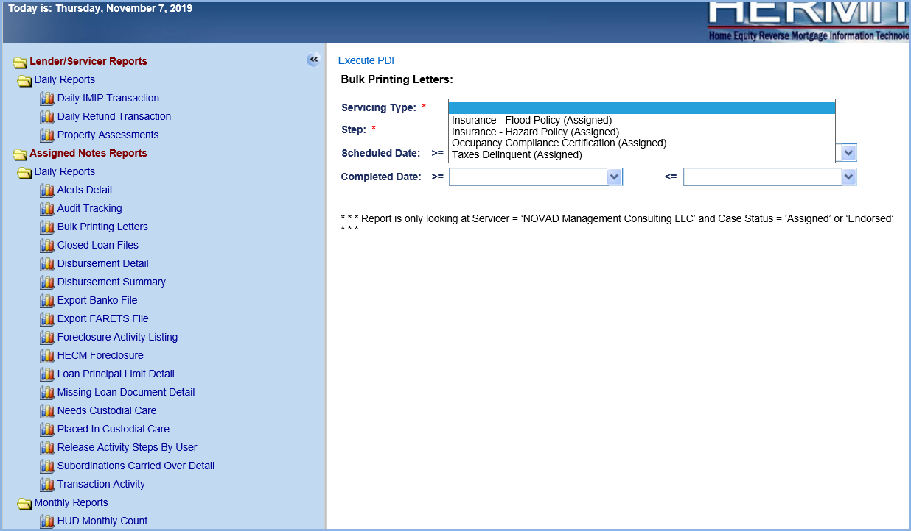

1. Following error message has been removed from the system

**Error Message**: The result records (number) is more than the limit 800

1. Following messages for users will be displayed while printing of letters.

**Example**: If the total result count for the letter is 1250 for today.

* There are 1250 letters, Do you wish to print the first 600?  If yes, once completed please rerun this search and print the remaining.
* There are 650 letters, Do you wish to print the first 600?  If yes, once completed please rerun this search and print the remaining.
* 50 letters have been retrieved. Do you wish to print these letters?

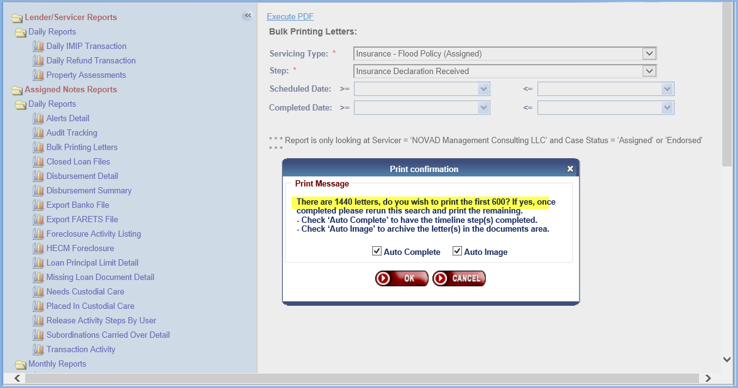

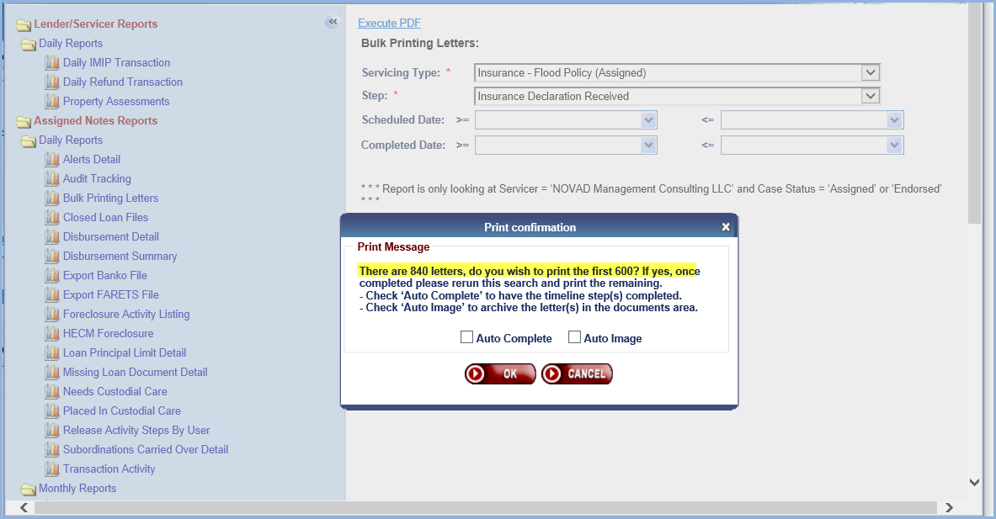

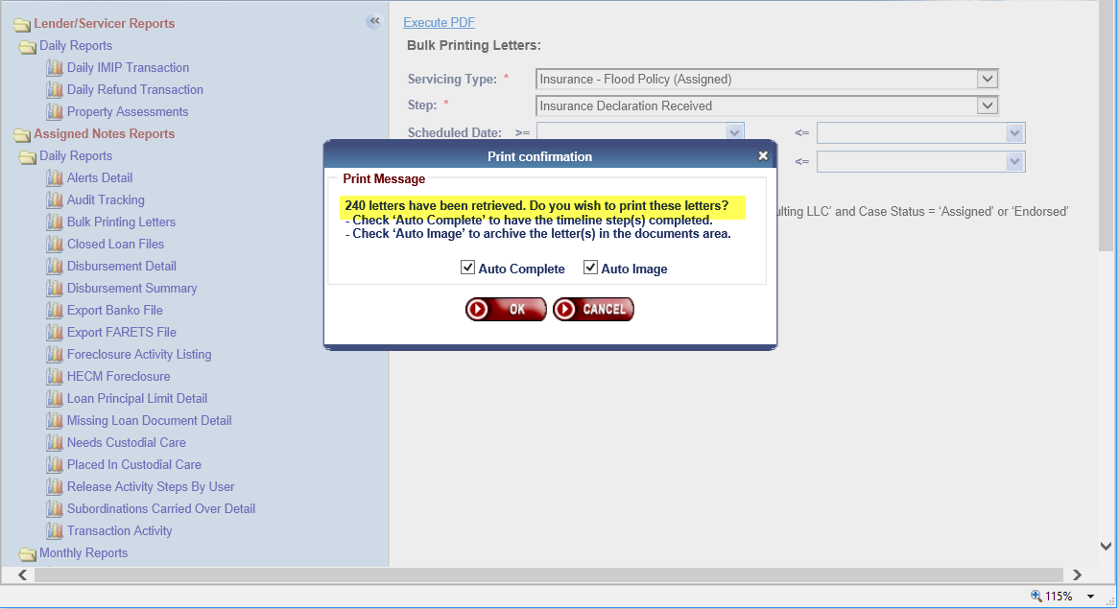

## ASSIGNED: New Repay Transaction for Property Charges on loans serviced by HUD Contractor

1. New Transaction Code (2717) was created for Repay transaction towards balance of all transactions listed below. The new Transaction is called “Part Repay - Prop Chrg/T&I Repayment”. Repay transaction will have an adjustment Transaction Code (2797). Adjustment transaction is called “Part Repay – Prop Chrg/T&I Repayment Adj.”

| **Trans Code** | **Trans Description** | **Adj Trans Code** | **Adj Trans Description** |
| --- | --- | --- | --- |
| 1355 | Disb - LOC- Property Charge- Ground Rent | 1395 | Disb - LOC- Prop Charge- Ground Rent Adj |
| 1356 | Disb - LOC- Property Charge- Flood Ins | 1396 | Disb - LOC- Prop Charge- Flood Ins Adj |
| 1357 | Disb - LOC- Property Charge-HOA Dues | 1397 | Disb - LOC- Prop Charge- HOA Dues Adj |
| 1358 | Disb - LOC- Property Charge-Condo Dues | 1398 | Disb - LOC- Prop Charge- Condo Due Adj |
| 2350 | Disb - Unscheduled from LOC Taxes | 2390 | Disb - Unscheduled from LOC Taxes - Adj |
| 2351 | Disb - LOC- Property Charge- Assessment | 2391 | Disb - LOC- Prop Charge- Assessment Adj |
| 2450 | Disb - Unscheduled from LOC Insurance | 2490 | Disb - Unscheduled from LOC Insur - Adj |
| 1650 | Disb - 1st Yr TI Set Aside Not Final | 1690 | Disb - 1st Yr TI Set Aside Not Final Adj |
| 1651 | Disb - 1st Yr TI Set Aside Final | 1691 | Disb - 1st Yr TI Set Aside Final Adj |

1. The Repay transaction can be entered via the UI on the Loan > Transactions/ Loan page and will be restricted to loans serviced by HUD where the Servicer ID is 9999909990.
2. New transaction will be available under existing Transaction Category: Repays

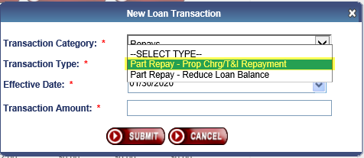

1. New transaction follows the waterfall approach.

* MIP Amount
* Service Fee
* Interest Amount
* Principal Amount

1. Multiple Repay transactions can be created on the same FHA Case Number
2. When entering Repay transaction amount, system will check against the total for the transactions listed above under section A. Transactions listed must be added by HUD Contractors. Any transactions added by Servicers will not be included in total
3. New field on Loan Balance page under Other Balances section. This field is called “Unscheduled Prop Chrg”. This field shows remaining category balance.

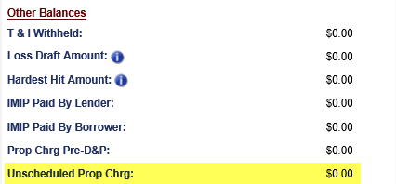

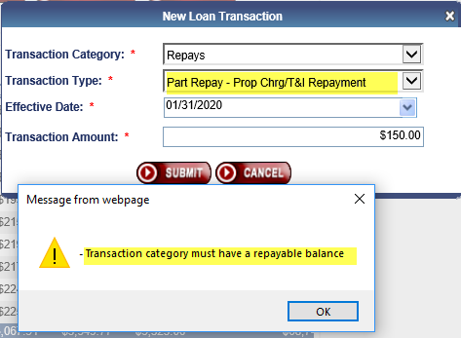

1. The Repay transaction amount cannot exceed the total from transactions listed in table above under section A. A hard stop will prevent the user to enter more than category total.
2. Error: Transaction Amount must be <= transaction category balance of {Total}

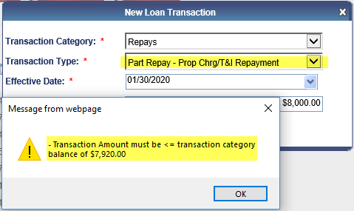

1. The Repay transaction will be part of Assigned Notes-Other batch type
2. Single Family Data Warehouse (SFDW) will receive these 2 new transaction codes.
3. These transactions are not available via B2G or Servicer transactions since they are only available for loans serviced by HUD

## ASSIGNED: Notes Disbursement Through Treasury

Changes were made to the process of disbursements in this release. Refer to the Training Materials and User Guide for updates to this process.